CIS355A Week 6 Lab—Database Connectivity

OBJECTIVES
- Programmatic access to a MySQL database to add and display records

PROBLEM: Student Management System
A teacher needs the ability to store and retrieve student data. This includes
- student name;
- three test scores;
- average; and
- letter grade.

FUNCTIONAL REQUIREMENTS
You can code the GUI by hand or use NetBeans GUI builder interface.
Create a GUI which allows for input and display of student data.
It should include buttons to save a record, display all records.

Create a database and table to store student name and three test scores. (Note that average and grade are calculated by app.)

Student class
Create a Student class to manage the student data. It should have private instance variables of
- student name; and
- three test scores.
The class must have the following methods.
- A default and parameterized constructor
- Sets/gets for all instance variables
- A get method to calculate and return the average
- A get method to calculate and return the letter grade
- toString to display the name of the student

StudentDB class
Create a StudentDB class that is used to create a connection and interface with the database.

This class should have two methods.
- getAll—reads data from database, returns data in an arraylist of student objects
- add—writes a record to the database

GUI class

Insert button will take the info from the GUI (student name and three test scores) and insert a record into the table. Input should be cleared from the textboxes.

Display button will read the data from the database and creates a report in Console window, sample format below.

Name Test1 Test2 Test3 Avg Grade
Bruce Wayne 90 95 98 94.3 A
Clark Kent 65 70 90 75.0 C

Sample GUI

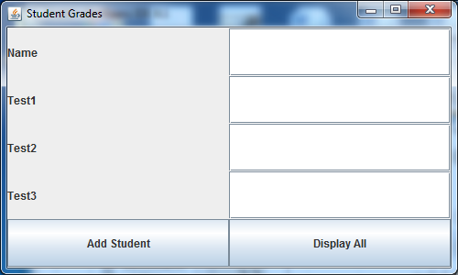

RUBRIC
Student class  - Has all required functionality | 10
GUI class  - Student record can be saved  - All student data can be displayed | 15
StudentDB class  - add method inserts a record into db.  - get method reads all records and returns in arraylist. | 15
Code style | 5
Lab Report | 10
TOTAL | 55

CODE STYLE REQUIREMENTS
- Include meaningful comments throughout your code.
- Use meaningful names for variables.
- Code must be properly indented.
- Include a comment header at beginning of each file, example below.
/****************************************************
Program Name: ProgramName.java
Programmer's Name: Student Name
Program Description: Describe here what this program will do
***********************************************************/

DELIVERABLES
Submit as a SINGLE zip folder
- all java files; and
- the Lab report.

Follow assignment specification regarding class/method names.
Note that your Java file name must match class name (DO NOT rename).

